ABOUT US

~~TITTLE( A CULTURE OF EXCELENCE )~~

CHESTER HAMILTON LLC is a very respected and experienced building and civil construction company. For about a decade, we have been transforming the dreams and visions of our clients into reality. Our goal is to exceed our clients’ expectations for quality, functionality, safety and esthetics, and deliver quality finished products that will stand the test of time.

American owned and operated since 2005, we have grown from a small local subcontractor into a capable and trusted provider of construction services. Though we have a far more reaching presence today, we are deeply rooted in the communities where we build and live.

Our portfolio features project of varying sizes and complexity. But, more than the complexity of our projects, our goal has always been to provide world-class services to our clients, capacity for innovation and the ability to involve our communities in our project.

In 2013, Mr. Chester decided to advance into emerging markets by building projects in South Africa, Angola, and Kenya. We have been presented with new challenges and opportunities that our construction methods, technology, and training continue to evolve to meet these challenges. Despite the challenges our story continues to be one of trust.

SERVICES

CHESTER HAMILTON LLC has built a reputation in the industry because our success is defined by the success of our clients. With each project, we seek to earn our clients’ trust and respect and we are fully engaged with the client through the course of the project. We strongly believe that only by delivering exceptional client service can we earn and maintain the trust of our clients. CHESRTER HAMILTON LLC provides structural and civil engineering, as well as project management. Structural engineering services includes, but not limited to, structural design of buildings (industrial, commercial, institutional, recreational and residential), transportation (bridges, culverts, drainage, farm and agricultural structures)

Civil engineering services includes roadway design, site planning and development, project inspection, construction administration, project management(construction observation, cost estimate, material testing).

STRUCTUTAL ENGINEERING……

CHESTER HAMILTON LLC. Structuring engineering services provides services to private municipal and local organizations in addition to state and federal agencies. Our structural services include the structural design of buildings, transportation facilities and general structures. Our structural team is supported by cutting edge technology and our goal of providing exceptional services to our clients. We include the client in each phase of the project so as to deliver a safe functional and quality end product.

Structural Services offered

* Design and Build
* Consultancy
* Operations and maintenance
* Performance
* Preconstruction

Experience

* Bridges
* Buildings ( residential, educational, healthcare, sports, )
* Hydroelectric structures

CIVIL ENGINEERING

CHESTER HAMILTON LLC design – build delivery system provides our customers with a reasonable delivery time on our projects. This system provides our clients with a single source management service from conception to completion of a project, thereby delivering projects safely and guaranteeing a budget and schedule certainty. CHESTER HAMILTON also provides concrete services to its clients. We offer a range of concrete management services from scheduling to formwork design, testing and installation to concrete pour and finishing.

SERVICES

* Design-Build
* Scheduling
* Cost estimating
* Preconstruction
* Construction review/ consulting
* Purchasing
* Material testing
* Building information modeling
* Concrete Placement and finishing
* Formwork design and installation
* Concrete products and concept
* Concrete block design and finishing

EXPERIENCE

* Buildings
* Highway, bridges
* Water facilities
* Railway construction, expansions and improvement
* Airport expansions and renovation

PROJECT MANAGEMENT

CHESTER HAMILTON LLC is expanding our reach into emerging markets. After lengthy research into these markets CHESTER HAMILTON LLC is proud to introduce this division geared towards providing input constructability, budget, sustainability and logistics. Our team of trained professionals will work with our clients on ongoing and new projects to ensure that they receive the most financially solution to their project. From selecting the right building material to evaluating the lifecycle cost of a project, we ensure that our client is aware of the cost of executing their dream.

SERVICES

* Construction Management and consulting
* Development and turnkey delivery
* Feasibility Studies
* Cost evaluation for life cycle analysis
* Certification and legal documents
* Scheduling and workforce
* Sustainability concept and planning

EXPERIENCE

* Residential facilities
* Government buildings
* Academics facilities
* Hospitals and medical centers
* Office buildings agricultural facilities
* Sports complex
* Multifamily and student housing
* Churches

CONTACTS

Email our engineering Unit at new email address to [learn more](http://preengcon.com/index-5.html) about our solutions for companies bearing heavy costs on structural or civil engineering projects. No matter how big or small your organization is, we have a solution for every scale. If you are an existing customer looking for additional support, please email our support desk at new email address

Name

Email

Phone

Address

EMPLOYMENT

|  |  |  |  |  |  |
| --- | --- | --- | --- | --- | --- |
|  | |  | | --- | | http://preengcon.com/images/4_pic_1.jpg | | |  |  | | --- | --- | |  |  | | |

**Building Professionals**

Whether you are a recent graduate or have decades of experience, CHESTER HAMILTON offers opportunities for top-notch construction professionals at all stages of their careers. We provide the chance to work with — and learn from — the best and brightest construction professionals and to build some of the coolest, most sophisticated projects.

**Opportunities**

* [Environmental Manager](http://clarkconstruction.com/careers/environmental-manager)
* [Scheduler](http://clarkconstruction.com/careers/scheduler)
* [Director of Energy Technology – Energy & Structured Finance](http://clarkconstruction.com/careers/director-energy-technology-%E2%80%93-energy-structured-finance)
* [Civil Project Manager](http://clarkconstruction.com/careers/civil-project-manager)
* [Process Piping Estimator – Clark Civil](http://clarkconstruction.com/careers/process-piping-estimator-%E2%80%93-clark-civil)
* [Safety Professional](http://clarkconstruction.com/careers/safety-professional)
* [Civil Superintendent](http://clarkconstruction.com/careers/civil-superintendent)
* [Office Engineer](http://clarkconstruction.com/careers/office-engineer)
* [Project Manager](http://clarkconstruction.com/careers/project-manager)
* [Superintendent](http://clarkconstruction.com/careers/superintendent)

## Interns

Our internship program provides a realistic view of what it's like to work in construction through meaningful, hands-on experiences. From coordinating subcontractors and suppliers to surveying and setting control lines, our interns assume a wide variety of responsibilities during their time with CHESTER HAMILTON.

NEWS

# Current News

~~PROJECTS~~

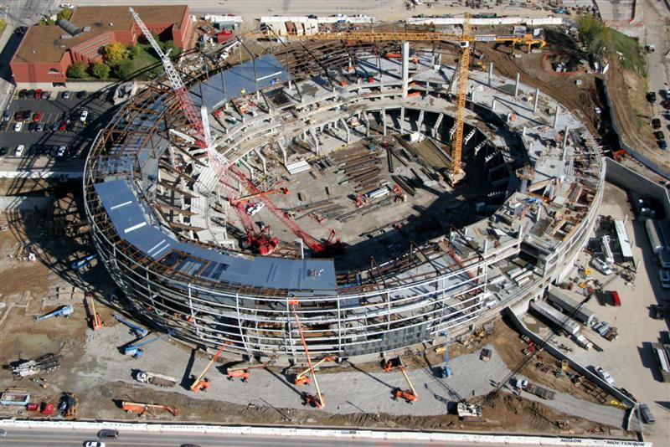

Sprint Arena structural (third party)

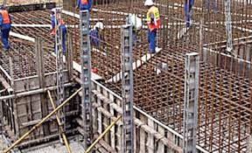

Intercontinental hotel (Kenya)

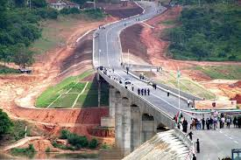

Tana River Bridge (Kenya)

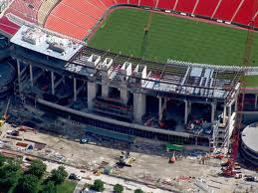

Arowhead stadium extension

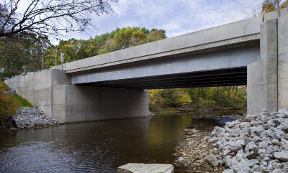

Bern St Bridge , Kansas city

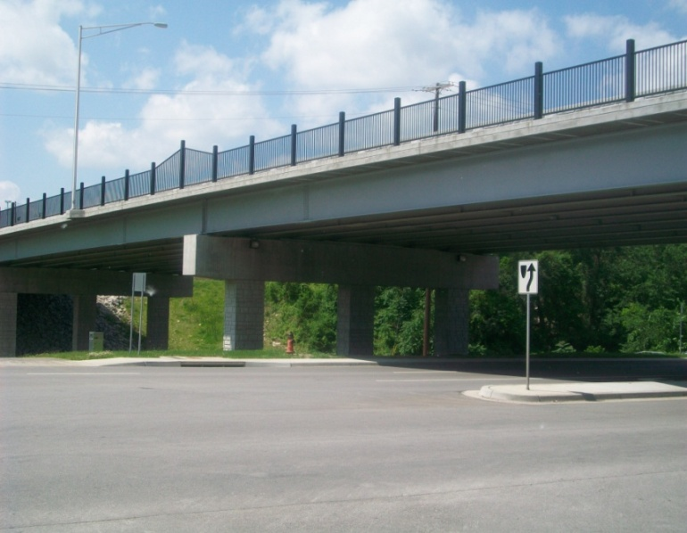

87th St Bridge Kansas City

]

Ygggff44xdgaz